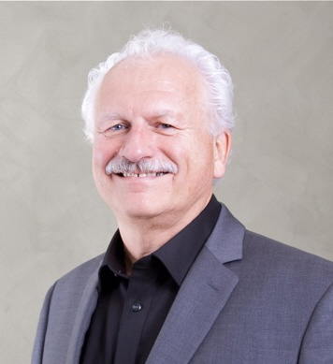

Rio Vista Rotary is proud to have been of service to our community for the past 60 years, and we’re proud to be a member of Rotary International, the world’s largest service organization, with over 1.2 million members worldwide. Rotary is an organization made up of business professionals and community leaders who volunteer their services to make their community and the world a better place to live. We hold fund raisers to support schools, youth groups, community projects, and other worthy causes. Rotary International promotes “Peace through Service” throughout the world, with projects to promote clean water and eliminate poverty. Rotary has almost completely eradicated Polio, which now affects only 1% of the world’s poplulation. This effort is the largest and most expensive project ever taken on by any organization.
You, too, can be a part of this amazing organization! Our meetings are held every Friday morning for breakfast, where we hear interesting speakers and enjoy the fun and fellowship of other Rotarians. You may make some of your best friends at Rotary. You must have someone in our membership sponsor you, so if you are interested, please email me at resler@citlink.net and I can arrange a meeting with you.
I hope you, too, will find a home in Rotary!
Gene Resler
President, 2012-2013

